Kalinga University
Faculty of Computer Science & Information Technology

Notes-IV

Course-BCSAIMLCS/BCAAIML
Subject-Deep Learning
Course Code- BCSAIMLCS502/BCAAIML502 Sem-V

Reinforcement Learning

Reinforcement Learning (RL) is a branch of machine learning that focuses on how agents can learn to make decisions through trial and error to maximize cumulative rewards. RL allows machines to learn by interacting with an environment and receiving feedback based on their actions. This feedback comes in the form of rewards or penalties.
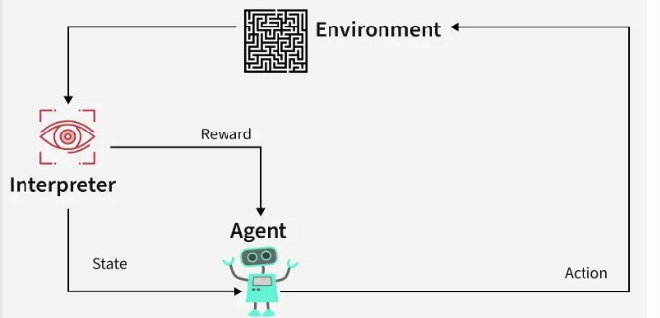
Reinforcement Learning revolves around the idea that an agent (the learner or decision-maker) interacts with an environment to achieve a goal. The agent performs actions and receives feedback to optimize its decision-making over time.
- Agent: The decision-maker that performs actions.
- Environment: The world or system in which the agent operates.
- State: The situation or condition the agent is currently in.
- Action: The possible moves or decisions the agent can make.
- Reward: The feedback or result from the environment based on the agent’s action.

How Reinforcement Learning Works?
The RL process involves an agent performing actions in an environment, receiving rewards or penalties based on those actions, and adjusting its behavior accordingly. This loop helps the agent improve its decision-making over time to maximize the cumulative reward.
Here’s a breakdown of RL components:
- Policy: A strategy that the agent uses to determine the next action based on the current state.
- Reward Function: A function that provides feedback on the actions taken, guiding the agent towards its goal.
- Value Function: Estimates the future cumulative rewards the agent will receive from a given state.
- Model of the Environment: A representation of the environment that predicts future states and rewards, aiding in planning.

Reinforcement Learning Example: Navigating a Maze
Imagine a robot navigating a maze to reach a diamond while avoiding fire hazards. The goal is to find the optimal path with the least number of hazards while maximizing the reward:
- Each time the robot moves correctly, it receives a reward.
- If the robot takes the wrong path, it loses points.
The robot learns by exploring different paths in the maze. By trying various moves, it evaluates the rewards and penalties for each path. Over time, the robot determines the best route by selecting the actions that lead to the highest cumulative reward.
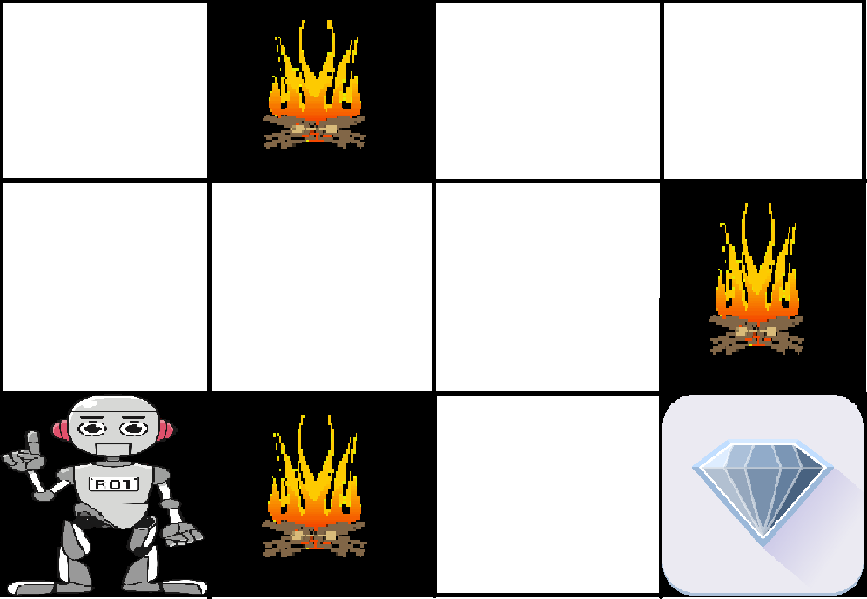
The robot's learning process can be summarized as follows:
- Exploration: The robot starts by exploring all possible paths in the maze, taking different actions at each step (e.g., move left, right, up, or down).
- Feedback: After each move, the robot receives feedback from the environment:
  - A positive reward for moving closer to the diamond.
  - A penalty for moving into a fire hazard.
- Adjusting Behavior: Based on this feedback, the robot adjusts its behavior to maximize the cumulative reward, favoring paths that avoid hazards and bring it closer to the diamond.
- Optimal Path: Eventually, the robot discovers the optimal path with the least number of hazards and the highest reward by selecting the right actions based on past experiences.

Understanding the Basics of Reinforcement Learning
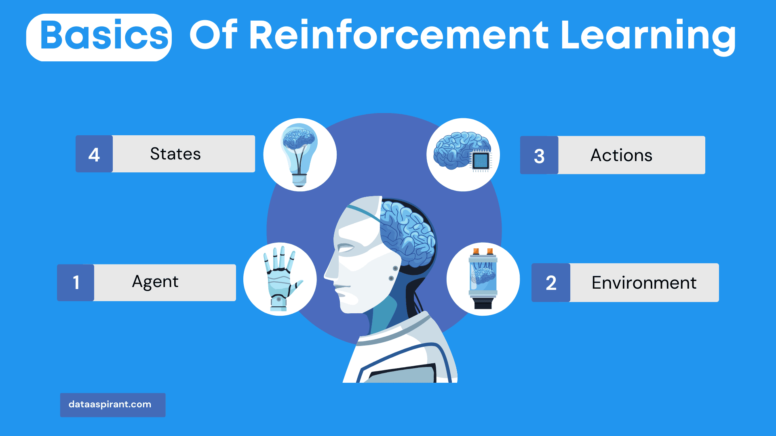
Understanding the basics of Reinforcement Learning, including the key components (agent, environment, actions, and states), the role of reward and punishment signals, and the exploration-exploitation trade-off, is essential for harnessing the power of RL to develop intelligent and adaptive AI systems.

Agent, Environment, Actions, and States
Reinforcement Learning revolves around the interaction between four key components:
- Agent,
- Environment,
- Actions,
- States.

Agent
An agent is the decision-making entity that learns from its experiences and interactions within the environment. It can be an AI system, a robot, or any other autonomous system capable of making decisions and taking action.

Environment
The environment is the context in which the agent operates. It defines the external conditions, constraints, and dynamics that influence the agent's decisions and actions. The environment can be real-world, simulated, or a combination of both.

Actions
Actions are the set of possible moves or decisions the agent can make in a given state. An agent's goal is to find the optimal action or sequence of actions to achieve its objective, such as maximizing rewards or achieving a specific goal.

States
States are the representations of the agent's knowledge or perception of the environment at a given moment. A state is typically defined by a set of features or variables that capture the relevant aspects of the environment for decision-making.
States serve as the basis for choosing actions and updating the agent's knowledge as it interacts with the environment.

Reward and Punishment Signals
In Reinforcement Learning, the agent learns from feedback provided by the environment in the form of rewards and punishments.

Reward
A reward is a positive feedback signal given to the agent when it takes an action that brings it closer to achieving its goal or improves its performance.
The agent's objective is to maximize the cumulative reward it receives over time. Rewards provide the agent with an indication of which actions are beneficial and should be reinforced.

Punishment
Punishment is a negative feedback signal given to the agent when it takes an action that hinders its progress or impairs its performance. Punishments help the agent learn which actions to avoid in order to improve its overall performance.
The feedback loop created by rewards and punishments is crucial for the agent's learning process. The agent updates its internal model or policy based on the feedback received, enabling it to make better decisions in the future.

Exploration and Exploitation Trade-off
A key challenge in Reinforcement Learning is balancing the trade-off between exploration and exploitation.

Exploration
Exploration is the process of trying out new actions or strategies to discover their potential benefits. By exploring, the agent can gather information about the environment and identify potentially better actions it may not have considered.
Exploration is crucial for the agent to learn about the environment and avoid getting stuck in suboptimal strategies.

Exploitation
Exploitation is the process of taking the best-known action, based on the agent's current knowledge and experience, to maximize its immediate reward. By exploiting, the agent leverages its existing knowledge to achieve its objectives more efficiently.
The exploration-exploitation trade-off is a critical aspect of the learning process in Reinforcement Learning.
Striking the right balance between exploration and exploitation is essential for achieving optimal performance:
- If the agent focuses less on exploration, it may save time and resources trying out less effective actions, leading to suboptimal performance in the short term.
- On the other hand, if the agent focuses too much on exploitation, it may miss out on discovering potentially better actions and strategies, resulting in suboptimal performance in the long run.
Various strategies and algorithms exist for managing the exploration-exploitation trade-off, such as
- ε-greedy,
- Upper Confidence Bound (UCB),
- Thompson Sampling.
Each of these approaches has its merits and limitations, and the choice of strategy depends on the agent's specific problem, environment, and objectives.

Types of Reinforcements in RL

1. Positive Reinforcement
Positive Reinforcement is defined as when an event, occurs due to a particular behavior, increases the strength and the frequency of the behavior. In other words, it has a positive effect on behavior.
- Advantages: Maximizes performance, helps sustain change over time.
- Disadvantages: Overuse can lead to excess states that may reduce effectiveness.

2. Negative Reinforcement
Negative Reinforcement is defined as strengthening of behavior because a negative condition is stopped or avoided.
- Advantages: Increases behavior frequency, ensures a minimum performance standard.
- Disadvantages: It may only encourage just enough action to avoid penalties.

CartPole in OpenAI Gym
One of the classic RL problems is the CartPole environment in OpenAI Gym, where the goal is to balance a pole on a cart. The agent can either push the cart left or right to prevent the pole from falling over.
- State space: Describes the four key variables (position, velocity, angle, angular velocity) of the cart-pole system.
- Action space: Discrete actions—either move the cart left or right.
- Reward: The agent earns 1 point for each step the pole remains balanced.

Application of Reinforcement Learning
- Robotics: RL is used to automate tasks in structured environments such as manufacturing, where robots learn to optimize movements and improve efficiency.
- Game Playing: Advanced RL algorithms have been used to develop strategies for complex games like chess, Go, and video games, outperforming human players in many instances.
- Industrial Control: RL helps in real-time adjustments and optimization of industrial operations, such as refining processes in the oil and gas industry.
- Personalized Training Systems: RL enables the customization of instructional content based on an individual's learning patterns, improving engagement and effectiveness.

Advantages of Reinforcement Learning
- Solving Complex Problems: RL is capable of solving highly complex problems that cannot be addressed by conventional techniques.
- Error Correction: The model continuously learns from its environment and can correct errors that occur during the training process.
- Direct Interaction with the Environment: RL agents learn from real-time interactions with their environment, allowing adaptive learning.
- Handling Non-Deterministic Environments: RL is effective in environments where outcomes are uncertain or change over time, making it highly useful for real-world applications.

Disadvantages of Reinforcement Learning
- Not Suitable for Simple Problems: RL is often an overkill for straightforward tasks where simpler algorithms would be more efficient.
- High Computational Requirements: Training RL models requires a significant amount of data and computational power, making it resource-intensive.
- Dependency on Reward Function: The effectiveness of RL depends heavily on the design of the reward function. Poorly designed rewards can lead to suboptimal or undesired behaviors.
- Difficulty in Debugging and Interpretation: Understanding why an RL agent makes certain decisions can be challenging, making debugging and troubleshooting complex
Reinforcement Learning is a powerful technique for decision-making and optimization in dynamic environments. However, the complexity of RL necessitates careful design of reward functions and substantial computational resources. By understanding its principles and applications, RL can be leveraged to solve intricate real-world problems and drive advancements across various industries.

Markov Decision Process

Markov Decision Process (MDP) is a way to describe how a decision-making agent like a robot or game character moves through different situations while trying to achieve a goal. MDPs rely on variables such as the environment, agent’s actions and rewards to decide the system’s next optimal action. It helps us answer questions like:
- What actions should the agent take?
- What happens after an action?
- Is the result good or bad?
In artificial intelligence Markov Decision Processes (MDPs) are used to model situations where decisions are made one after another and the results of actions are uncertain. They help in designing smart machines or agents that need to work in environments where each action might led to different outcomes.

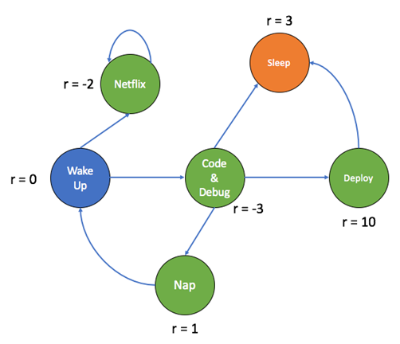

Key Components of an MDP
An MDP has five main parts:

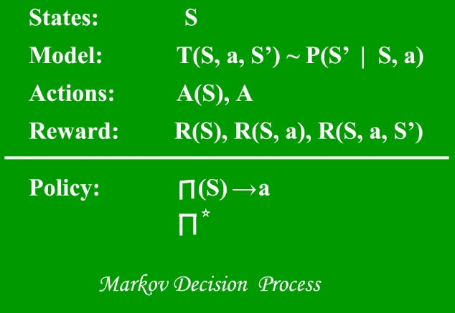
Components of Markov Decision Process
1. States (S):A state is a situation or condition the agent can be in. For example, A position on a grid like being at cell (1,1).
2. Actions (A): An action is something the agent can do. For example, Move UP, DOWN, LEFT or RIGHT. Each state can have one or more possible actions.
3. Transition Model (T): The model tells us what happens when an action is taken in a state. It’s like asking: “If I move RIGHT from here, where will I land?” Sometimes the outcome isn’t always the same that’s uncertainty. For example:
- 80% chance of moving in the intended direction
- 10% chance of slipping to the left
- 10% chance of slipping to the right
This randomness is called a stochastic transition.
4. Reward (R): A reward is a number given to the agent after it takes an action. If the reward is positive, it means the result of the action was good. If the reward is negative it means the outcome was bad or there was a penalty help the agent learn what’s good or bad. Examples:
- +1 for reaching the goal
- -1 for stepping into fire
- -0.1 for each step to encourage fewer moves
5. Policy (π): A policy is the agent’s plan. It tells the agent: “If you are in this state, take this action.” The goal is to find the best policy that helps the agent earn the highest total reward over time.
Let’s consider a 3x4 grid world. The agent starts at cell (1,1) and aims to reach the Blue Diamond at (4,3) while avoiding Fire at (4,2) and a Wall at (2,2). At each state the agent can take one of the following actions: UP, DOWN, LEFT or RIGHT

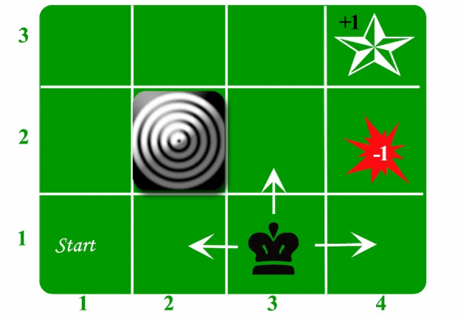
Problem

1. Movement with Uncertainty (Transition Model)
The agent’s moves are stochastic (uncertain):
- 80% chance of going in the intended direction.
- 10% chance of going left of the intended direction.
- 10% chance of going right of the intended direction.

2. Reward System
- +1 for reaching the goal.
- -1 for falling into fire.
- -0.04 for each regular move (to encourage shorter paths).
- 0 for hitting a wall (no movement or penalty).

3. Goal and Policy
- The agent’s objective is to maximize total rewards.
- It must find an optimal policy: the best action to take in each state to reach the goal quickly while avoiding danger.

4. Path Example
- One possible optimal path is: UP → UP → RIGHT → RIGHT → RIGHT
- But because of randomness the agent must plan carefully to avoid accidentally slipping into fire.

Applications of Markov Decision Processes (MDPs)
Markov Decision Processes are useful in many real-life situations where decisions must be made step-by-step under uncertainty. Here are some applications:
- Robots and Machines: Robots use MDPs to decide how to move safely and efficiently in places like factories or warehouses and avoid obstacles.
- Game Strategy: In board games or video games MDPs help characters to choose the best moves to win or complete tasks even when outcomes are not certain.
- Healthcare: Doctors can use it to plan treatments for patients, choosing actions that improve health while considering uncertain effects.
- Traffic and Navigation: Self-driving cars or delivery vehicles use it to find safe routes and avoid accidents on unpredictable roads.
- Inventory Management: Stores and warehouses use MDPs to decide when to order more stock so they don’t run out or keep too much even when demand changes.

Q-Learning in Reinforcement Learning

Q-Learning is a popular model-free reinforcement learning algorithm that helps an agent learn how to make the best decisions by interacting with its environment. Instead of needing a model of the environment the agent learns purely from experience by trying different actions and seeing their results
Imagine a system that sees an apple but incorrectly says, “It’s a mango.” The system is told, “Wrong! It’s an apple.” It learns from this mistake. Next time, when shown the apple, it correctly says “It’s an apple.” This trial-and-error process, guided by feedback is like how Q-Learning works.
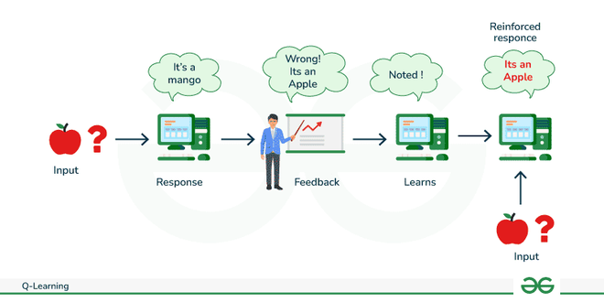
Q Learning
The core idea is that the agent builds a Q-table which stores Q-values. Each Q-value estimates how good it is to take a specific action in a given state in terms of the expected future rewards. Over time the agent updates this table using the feedback it receives

Key Components of Q-learning

1. Q-Values or Action-Values
Q-values represent the expected rewards for taking an action in a specific state. These values are updated over time using the Temporal Difference (TD) update rule.

2. Rewards and Episodes
The agent moves through different states by taking actions and receiving rewards. The process continues until the agent reaches a terminal state which ends the episode.

3. Temporal Difference or TD-Update
The agent updates Q-values using the formula:
Q(S,A)←Q(S,A)+α(R+γQ(S′,A′)−Q(S,A))Q(S,A)←Q(S,A)+α(R+γQ(S′,A′)−Q(S,A))
Where,
- S is the current state.
- A is the action taken by the agent.
- S' is the next state the agent moves to.
- A' is the best next action in state S'.
- R is the reward received for taking action A in state S.
- γ (Gamma) is the discount factor which balances immediate rewards with future rewards.
- α (Alpha) is the learning rate determining how much new information affects the old Q-values.

4. ϵ-greedy Policy (Exploration vs. Exploitation)
The ϵ-greedy policy helps the agent decide which action to take based on the current Q-value estimates:
- Exploitation: The agent picks the action with the highest Q-value with probability 1−ϵ1−ϵ. This means the agent uses its current knowledge to maximize rewards.
- Exploration: With probability ϵϵ, the agent picks a random action, exploring new possibilities to learn if there are better ways to get rewards. This allows the agent to discover new strategies and improve its decision-making over time.

How does Q-Learning Works?
Q-learning models follow an iterative process where different components work together to train the agent. Here's how it works step-by-step:

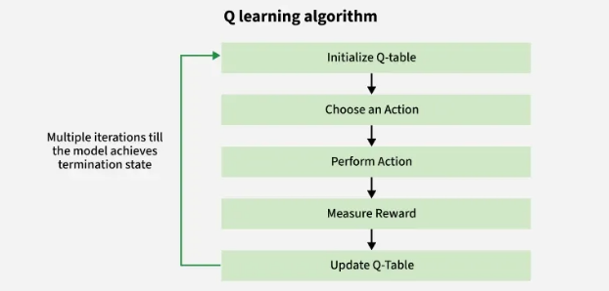
Q learning algorithm

1. Start at a State (S)
The environment provides the agent with a starting state which describes the current situation or condition.

2. Agent Selects an Action (A)
Based on the current state and the agent chooses an action using its policy. This decision is guided by a Q-table which estimates the potential rewards for different state-action pairs. The agent typically uses an ε-greedy strategy:
- It sometimes explores new actions (random choice).
- It mostly exploits known good actions (based on current Q-values).

3. Action is Executed and Environment Responds
The agent performs the selected action. The environment then provides:
- A new state (S′) — the result of the action.
- A reward (R) — feedback on the action's effectiveness.

4. Learning Algorithm Updates the Q-Table
The agent updates the Q-table using the new experience:
- It adjusts the value for the state-action pair based on the received reward and the new state.
- This helps the agent better estimate which actions are more beneficial over time.

5. Policy is Refined and the Cycle Repeats
With updated Q-values the agent:
- Improves its policy to make better future decisions.
- Continues this loop — observing states, taking actions, receiving rewards and updating Q-values across many episodes.
Over time the agent learns the optimal policy that consistently yields the highest possible reward in the environment.

Methods for Determining Q-values

1. Temporal Difference (TD):
Temporal Difference is calculated by comparing the current state and action values with the previous ones. It provides a way to learn directly from experience, without needing a model of the environment.

2. Bellman’s Equation:
Bellman’s Equation is a recursive formula used to calculate the value of a given state and determine the optimal action. It is fundamental in the context of Q-learning and is expressed as:
Q(s,a)=R(s,a)+γmax⁡aQ(s′,a)Q(s,a)=R(s,a)+γmaxa​Q(s′,a)
Where:
- Q(s, a) is the Q-value for a given state-action pair.
- R(s, a) is the immediate reward for taking action a in state s.
- γ is the discount factor, representing the importance of future rewards.
- maxaQ(s′,a)maxa​Q(s′,a) is the maximum Q-value for the next state s' and all possible actions.

What is a Q-table?
The Q-table is essentially a memory structure where the agent stores information about which actions yield the best rewards in each state. It is a table of Q-values representing the agent's understanding of the environment. As the agent explores and learns from its interactions with the environment, it updates the Q-table. The Q-table helps the agent make informed decisions by showing which actions are likely to lead to better rewards.
Structure of a Q-table:
- Rows represent the states.
- Columns represent the possible actions.
- Each entry in the table corresponds to the Q-value for a state-action pair.
Over time, as the agent learns and refines its Q-values through exploration and exploitation, the Q-table evolves to reflect the best actions for each state, leading to optimal decision-making.

Implementation of Q-Learning
Here, we implement basic Q-learning algorithm where agent learns the optimal action-selection strategy to reach a goal state in a grid-like environment.

Step 1: Define the Environment
Set up the environment parameters including the number of states and actions and initialize the Q-table. In this each state represents a position and actions move the agent within this environment.
import numpy as np

n_states = 16
n_actions = 4
goal_state = 15

Q_table = np.zeros((n_states, n_actions))

Step 2: Set Hyperparameters
Define the parameters for the Q-learning algorithm which include the learning rate, discount factor, exploration probability and the number of training epochs.
learning_rate = 0.8
discount_factor = 0.95
exploration_prob = 0.2
epochs = 1000

Step 3: Implement the Q-Learning Algorithm
Perform the Q-learning algorithm over multiple epochs. Each epoch involves selecting actions based on an epsilon-greedy strategy updating Q-values based on rewards received and transitioning to the next state.
for epoch in range(epochs):
current_state = np.random.randint(0, n_states)
while current_state != goal_state:
if np.random.rand() < exploration_prob:
action = np.random.randint(0, n_actions)
else:
action = np.argmax(Q_table[current_state])

next_state = (current_state + 1) % n_states

reward = 1 if next_state == goal_state else 0

Q_table[current_state, action] += learning_rate * \
(reward + discount_factor *
np.max(Q_table[next_state]) - Q_table[current_state, action])

current_state = next_state

Step 4: Output the Learned Q-Table
After training, print the Q-table to examine the learned Q-values which represent the expected rewards for taking specific actions in each state.
q_values_grid = np.max(Q_table, axis=1).reshape((4, 4))

# Plot the grid of Q-values
plt.figure(figsize=(6, 6))
plt.imshow(q_values_grid, cmap='coolwarm', interpolation='nearest')
plt.colorbar(label='Q-value')
plt.title('Learned Q-values for each state')
plt.xticks(np.arange(4), ['0', '1', '2', '3'])
plt.yticks(np.arange(4), ['0', '1', '2', '3'])
plt.gca().invert_yaxis() # To match grid layout
plt.grid(True)

# Annotating the Q-values on the grid
for i in range(4):
for j in range(4):
plt.text(j, i, f'{q_values_grid[i, j]:.2f}', ha='center', va='center', color='black')

plt.show()

# Print learned Q-table
print("Learned Q-table:")
print(Q_table)
Output:
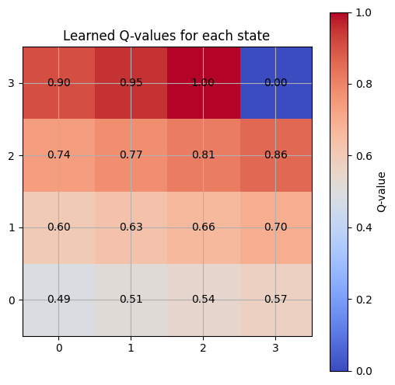Q values on grid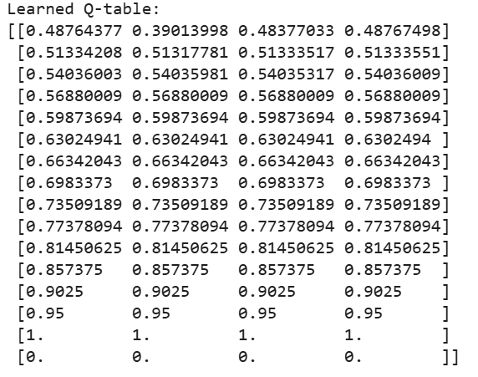
The learned Q-table shows the expected rewards for each state-action pair, with higher Q-values near the goal state (state 15), indicating the optimal actions that lead to reaching the goal. The agent's actions gradually improve over time, as reflected in the increasing Q-values across states leading to the goal.

Advantages of Q-learning
- Trial and Error Learning: Q-learning improves over time by trying different actions and learning from experience.
- Self-Improvement: Mistakes lead to learning, helping the agent avoid repeating them.
- Better Decision-Making: Stores successful actions to avoid bad choices in future situations.
- Autonomous Learning: It learns without external supervision, purely through exploration.

Disadvantages of Q-learning
- Slow Learning: Requires many examples, making it time-consuming for complex problems.
- Expensive in Some Environments: In robotics, testing actions can be costly due to physical limitations.
- Curse of Dimensionality: Large state and action spaces make the Q-table too large to handle efficiently.
- Limited to Discrete Actions: It struggles with continuous actions like adjusting speed, making it less suitable for real-world applications involving continuous decisions.

Real-world Applications of Reinforcement Learning

- 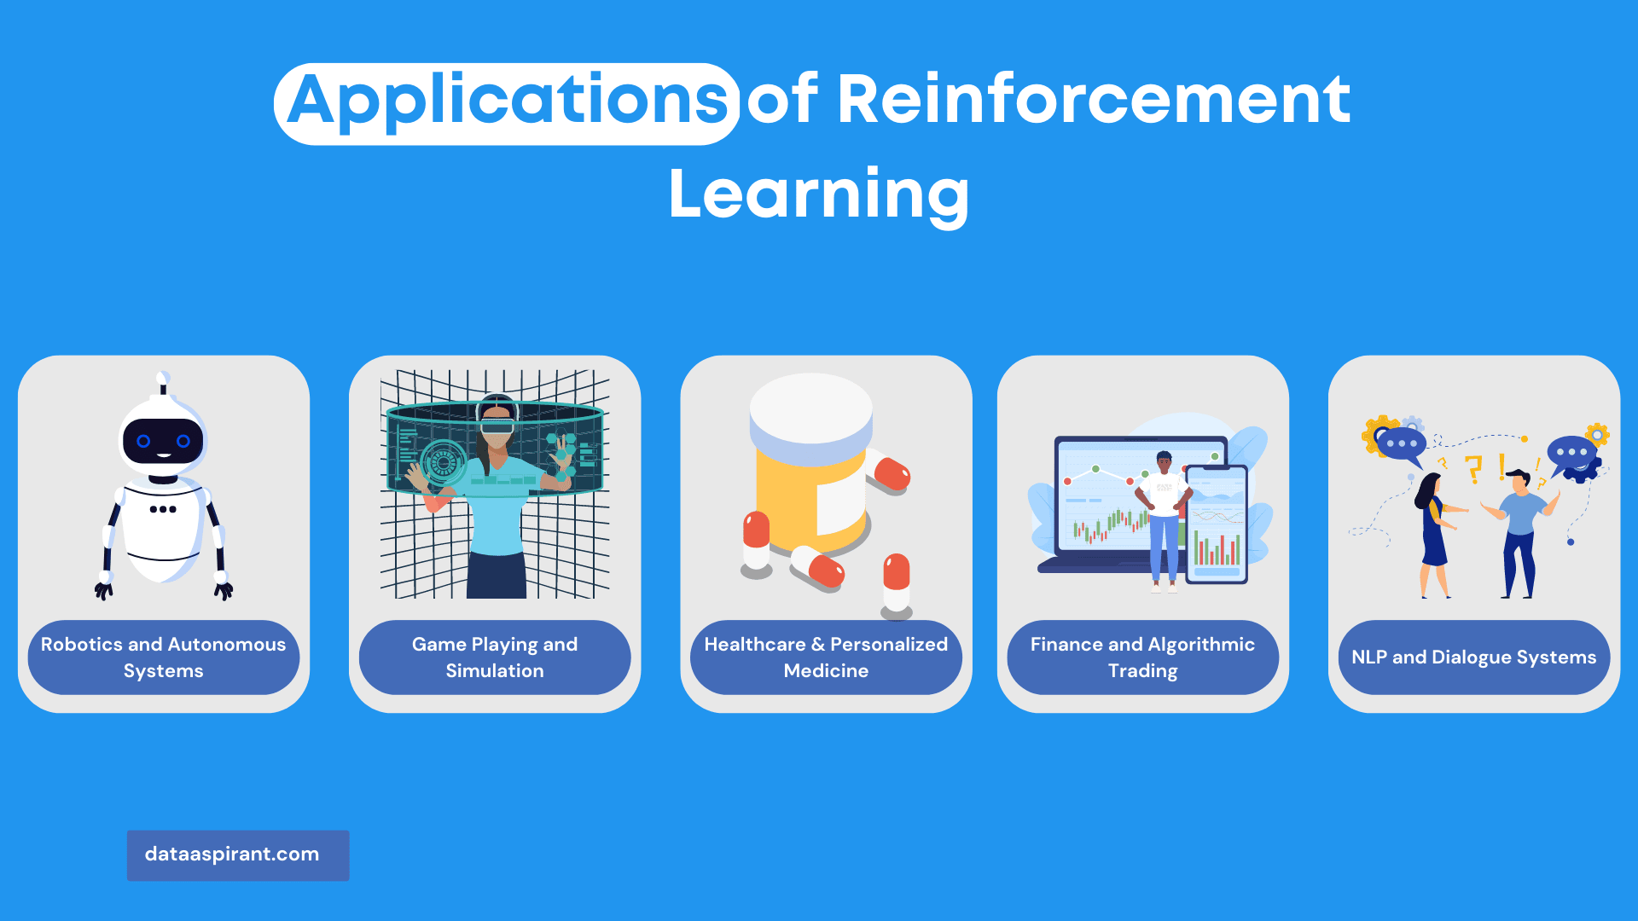

Robotics and Autonomous Systems
Reinforcement learning has been successfully applied to robotics and autonomous systems, enabling robots to learn complex tasks like manipulation, locomotion, and navigation.
RL allows robots to learn from trial and error, adapting to new situations and improving their performance over time.

Game Playing and Simulation
RL has been used to train agents to play various games, from classic board games like Go and chess to modern video games like Atari and Dota 2.
These agents often achieve superhuman performance, demonstrating the potential of RL to solve complex decision-making problems.

Healthcare and Personalized Medicine
In healthcare, RL can be used to personalize treatment plans, optimize drug dosing, and assist in diagnosing and managing diseases.
By learning from patient data, RL algorithms can help improve patient outcomes and reduce healthcare costs.

Finance and Algorithmic Trading
Reinforcement learning has been applied to finance and algorithmic trading, where agents learn to make optimal investment decisions, execute trades, and manage portfolios.
RL can help improve trading strategies, manage risk, and adapt to changing market conditions.

Natural Language Processing and Dialogue Systems
In natural language processing (NLP), RL can be used to train dialogue systems, chatbots, and virtual assistants. By learning from interactions with users, RL-based dialogue systems can provide more relevant and engaging responses, improving the overall user experience.

Challenges and Limitations of Reinforcement Learning

Sample Inefficiency and Exploration
Reinforcement learning often requires a large number of samples to learn an optimal policy, making it computationally expensive and time-consuming. Efficient exploration strategies are essential for mitigating this issue, but designing effective exploration techniques remains a challenging problem.

Scalability and Generalization
RL algorithms can need help to scale and generalize to new, unseen situations as the size and complexity of the state and action spaces increase. Developing RL algorithms that can handle high-dimensional, continuous state-action spaces is an active area of research.

Sparse and Delayed Rewards
In many real-world problems, rewards are sparse or delayed, making it difficult for the agent to associate its actions with their consequences. This can lead to slow learning and poor performance. Developing techniques to handle sparse and delayed rewards is crucial for the success of RL in practical applications.

Stability and Convergence Issues
The stability and convergence of RL algorithms can be affected by factors like function approximation, exploration strategies, and learning rates. Ensuring the stability and convergence of RL algorithms is important for their practical applicability.

Ethical Considerations and AI Safety
Ethical considerations and AI safety become paramount as RL algorithms are applied to increasingly complex and critical domains. Ensuring RL agents act safely, responsibly, and transparently is essential for widespread adoption.

Future Directions in Reinforcement Learning

Transfer Learning and Domain Adaptation
Transfer learning aims to leverage knowledge gained in one domain to improve performance in another related domain. Developing RL techniques that can effectively transfer and adapt to new environments will be essential for creating more flexible and efficient learning algorithms.

Multi-agent Reinforcement Learning
In many real-world scenarios, multiple agents interact and learn simultaneously. Studying multi-agent reinforcement learning can lead to the development of algorithms that can handle competitive and cooperative scenarios, enabling more complex and intelligent decision-making systems.

Hierarchical Reinforcement Learning
Hierarchical reinforcement learning (HRL) aims to break down complex tasks into smaller, more manageable sub-tasks. This can improve learning efficiency and make scaling RL algorithms to larger problems easier. Advancements in HRL will enable more sophisticated RL applications.

Imitation Learning and Inverse Reinforcement Learning
Imitation learning and inverse reinforcement learning involve learning from demonstrations or examples provided by an expert or human demonstrator.
hese approaches can help overcome some of the challenges in traditional RL, such as sample inefficiency and exploration. Integrating these techniques with RL can lead to more efficient and effective learning algorithms.

Integrating RL with Other Machine Learning Techniques
Combining reinforcement learning with other machine learning techniques, such as supervised, unsupervised, and deep learning, can lead to more powerful and versatile learning algorithms. This integration can help overcome some of the challenges and limitations of standalone RL methods.

Conclusion
Reinforcement learning plays a crucial role in the field of artificial intelligence, enabling agents to learn from their interactions with the environment and optimize their actions to achieve specific goals. As a result, RL has become a critical component in the development of intelligent systems across various domains.
Given the tremendous potential of reinforcement learning and its wide-ranging applications, we encourage readers to delve deeper into the field, experiment with different RL techniques, and stay up-to-date with the latest research and developments.
As reinforcement learning continues to evolve and mature, its impact on AI and its applications is expected to grow significantly.
By overcoming current challenges and limitations, RL has the potential to revolutionize various industries, from robotics and healthcare to finance and natural language processing.
Embracing and harnessing the power of reinforcement learning will be crucial for shaping the future of AI and driving innovation across a multitude of fields.

